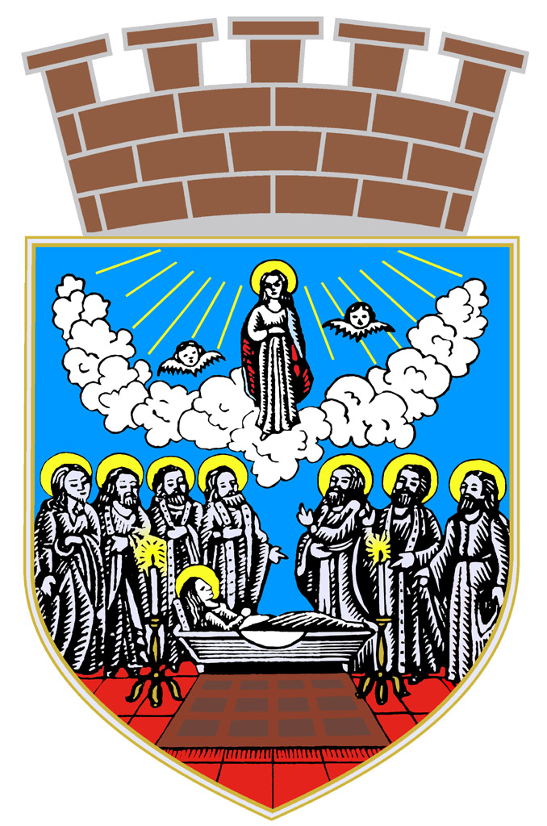 | 57.Balkan Cross Country Championships  Prvenstvo Balkana u krosu  Zrenjanin/Serbia, 09.03.2013. | 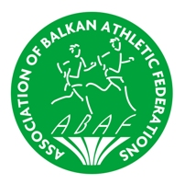

PRELIMINARY TIME TABLE
PRELIMINARNA SATNICA TAKMIČENJA

Call room  time | Start  time
 | 10.30 | OPENING CEREMONY / otvaranje takmičenja
10.45 | 11.00 | 4km | JUNIOR WOMEN / juniorke
11.10 | 11.25 | 6km | JUNIOR MEN / juniori
 | 11.30 | Victory ceremony  proglašenje pobednika | JUNIORE WOMEN / juniorke
11.40 | 11.55 | 6km | WOMEN U23 / mlađe seniorke
 | 12.00 | Victory ceremony  proglašenje pobednika | JUNIOR MEN / juniori
12.10 | 12.25 | 8km | MEN U23 / mlađi seniori
 | 12.30 | Victory ceremony  proglašenje pobednika | WOMEN U23 / mlađe seniorke
12.40 | 12.55 | 8km | SENIOR WOMEN / seniorke
 | 13.00 | Victory ceremony  proglašenje pobednika | MEN U23 / mlađi seniori
13.20 | 13.35 | 10km | SENIOR MEN / seniori
 | 13.40 | Victory ceremony  proglašenje pobednika | SENIOR WOMEN / seniorke
 | 14.15 | Victory ceremony  proglašenje pobednika | SENIOR MEN / seniori

15.30 SVEČANI RUČAK - PROGLAŠENJE EKIPNIH POBEDNIKA
Closing bonquet - Announcing of Team Winner

